# **Department of Computer Science and Engineering Islamic University of Technology (IUT)** A subsidiary organ of OIC

# **Laboratory Report**

# CSE 4412: Data Communication and Networking Lab

## 

|  |  |
| --- | --- |
| **Name** | **: Chowdhury Ashfaq** |
| **Student ID** | **: 200042123** |
| **Section** | **: A** |
| **Semester** | **: Winter** |
| **Academic Year** | **: 2021-22** |
| **Date** | **: 17/01/23** |
| **Lab No** | **: 3** |

### 

### **Title:** Create a simple basic LAN (Local Area Network)

### **Objective**:

1. Create a simple LAN by connecting multiple end devices.
2. Significance of IP address
3. Difference between Switch and Hub.
4. Configure the given topology (see .pkt file in the attachment) to create LAN.

### **Devices/ software Used**: Cisco Packet Tracer, Command Line.

### **Working Procedure:**

Our main goal in this experiment is to create a Local Area Network or LAN. For creating LAN we need to have idea about some terms: 1) IP Address, 2) Subnet Mask, 3) Network ID, and 4) Wiring between devices.

In a LAN the key concept is the Network ID. In any local area network all of the devices that exists must have the same Network ID. Again we know that every device itself has an unique IP address. So how can we get same Network ID for different devices? This is were subnet masks concept comes up.

Subnet Mask is a 4 partitioned dotted value which would be same for a particular network. IP address is also a 4 partitioned dotted value each of whose part can have value from 0- (28-1). The Network ID is found by the AND operation between IP Address and Subnet Mask.

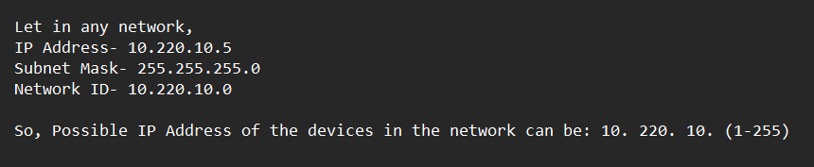

We move on to Cisco Packet Tracer and then we insert 4 PC’s each on Room 101, 102, and 103. On Room 101 and 102 we insert one hub on each room. The 3rd room doesn’t have any switch or hub. Each PC on room 101 and 102 is connected to the hub of their respective rooms with Straight-through cable. Then we insert a central switch where the hubs of room 101 and 102 are connected via Cross-over cable. Next all of the PC’s of room 103 are also connected directly to the central switch with the help of Straight-through cable.

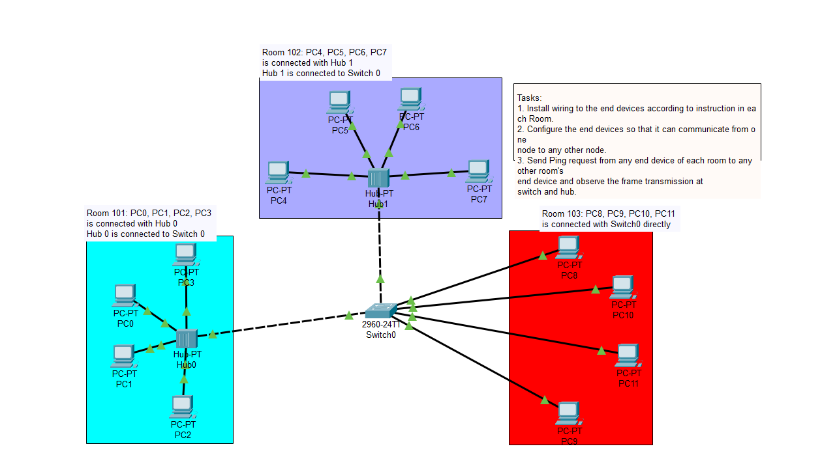

Then we’d need to configure each PC so that the Network ID of all PC’s remain same as they are connected to a central switch. For the first PC we set IP address as 10.200.20.2 and see the subnet mask to be 255.0.0.0. This means that the possible IP address could be 10.(1-255). (1-255). (1-255). So, we set the IP address of other 3 computers of room 101 as 10.200.20.1, 10.200.20.3 and 10.200.20.4.

For Room 102 we set IP addresses as 10.200.10.11, 10.200.10.12, 10.200.10.13 and 10.200.10.14. In room 103 the IP addresses are 10.100.10.1, 10.100.10.2, 10.100.10.3 and 10.100.10.4.

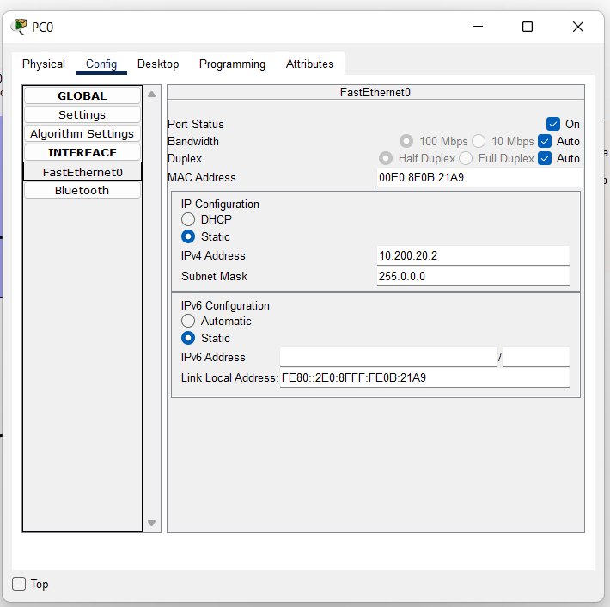

Next we try to ping PC of other rooms to confirm if they’re connected to the same network or not. For that, we open the Command Line of PC3 of room 101. In the command line we write ‘ping 10.100.10.1’ to ping PC8 of room 103 and it was successful. Similarly we try to ping PC5 of room 102 and it was successful as well.

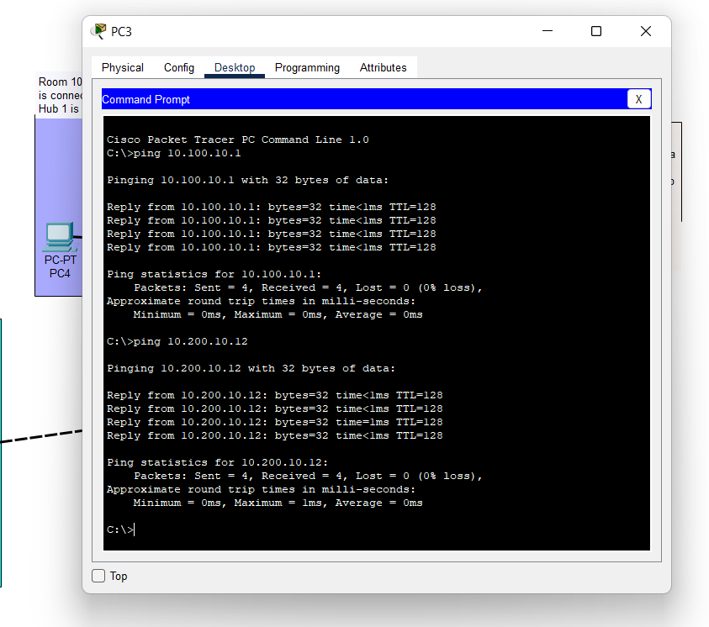

Next we add Simple PDU from PC3 of room 101 to PC9 of room 103 and capture the results of eventlist after simulating.

### **Diagram of the experiment:**





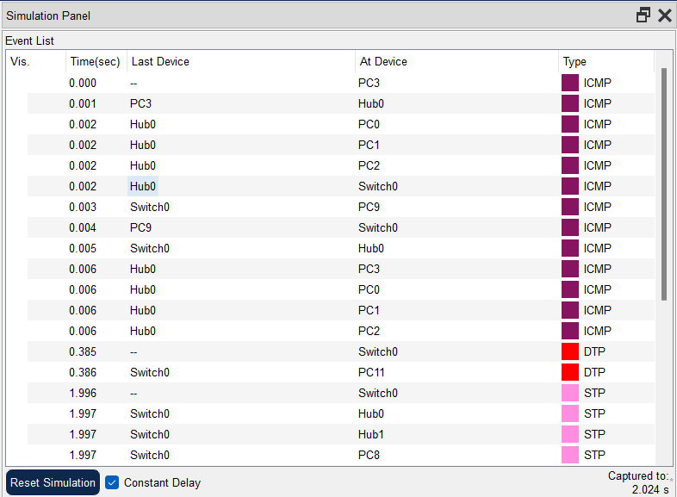

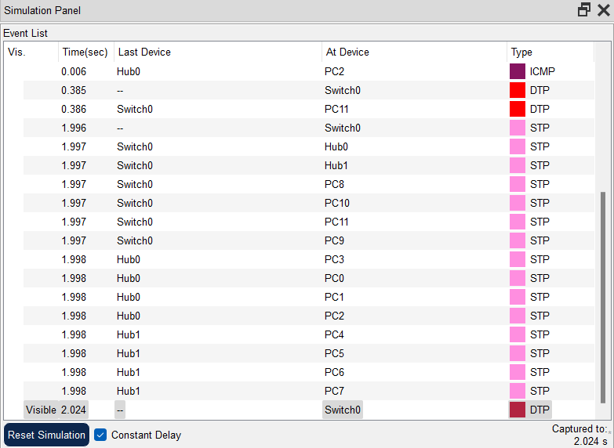

### **Observation**:

* **Significance of IP address configuration to different end devices:**

**Uniquely identifies any device on any network.**

* **Difference between Switch and Hub:**

**Switch is Layer-2 device while hub is layer-1 device.**

* **Network ID of all devices under a network have to be same.**
* **ICMP used for diagnostics of IP address.**
* **DHCP automatically assigns IP address. If DHCP isn’t present IP address have to be configured manually.**
* **Flooding occurs when message is sent before switch can process info of new PC or insert into the table.**

### **Challenges:**

* Not understanding whether PC or switch or hub is turned on or off.
* The process of setting up IP address for a PC in Cisco.
* Hard to understand the simulation after PDU is sent from one device to other.